SHERWIN C. MANADA, CPA

PS/Acting General Manager

NEA-LANECO

Thru: Sir JIMMY S. ESCULTO

System Administrator

Mrs. ANGELINA G. ESTROLOGO

Finance Manager

**Compiling complete source code of Read and Bill android application and Altering UCSD Charge Rate Computation**

The necessity of Read and Bill android application is an absolutely need of each every electric cooperative. It helps to maximize the numbers of meter reads every day and reduce the time of reading and serving electric bill to the member consumers.

But since the android developer has only limited time to handle the application development of LANECO, which causes delayed implementation of additional rate computation. The coop. “System Administrator” has eyeing a complete compile “Source Code” for them to ease the enhancement of Read and Bill android app.

1. **These are the complete compiling source code, the following:**
2. Uses two source code as reference for compiling
3. Old source code from previous developer

– Used as a format structural coding of the software.

1. Decode source code from APK

– Used to collect XML component and rate computation.

1. Fixed XML component missing codes.
2. Fixing of component IDs.
3. Recreate java class structure events to match the XML component.
4. Registered java class events into “Manifest” XML file. The android events controller.

1. **Altering UCSD Charge Rate Computation.**
2. Update SQLite rate table fields.
3. Update Compute charges java class.
4. Update SOA presentation.

**Complete Compile Source Code 13,000.00**

Including source code eclipse importation

**Altering UCSD Charge Rate Computation 2,000.00**

**P 15,000.00**

**Free debugging within 2 months after deployment.**

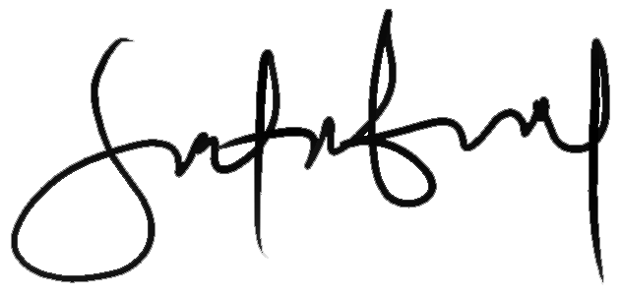

**RONEL M. SUTABINTO**